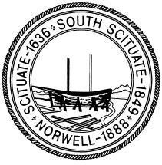

TOWN OF NORWELL
Amended Advisory Board Meeting Agenda
North River Room, Town Hall
November 25, 2025

Instructions: Zoom Access to Remote Participation for Open Meeting: Computer access: log on to Zoom application, type in Meeting ID: 590 544 2324, click on “join meeting”
Phone: +1 929 205 6099 Plus meeting ID: 590 544 2324 then #
* Remote Participation conducted pursuant to the Executive Order dated March 12, 2020, extended to March 31, 2025, suspending certain provisions of the Open Meeting Law, Gen. L.
c. 30A §20 et seq. and 940 CMR 29.01 et seq.

7:30pm Call to Order Approve Agenda
Approve Meeting Minutes as needed
Reserve Fund transfers as needed

Reorganization of Advisory Board and Liaison Appointments

Government Studies Discussion and Liaison Assignment

Town Administrator Update

Advisory Board approach to the review of town budgets

Future Meeting Dates

Adjourn

